Bahria University,

Karachi Campus



LAB EXPERIMENT NO.

**09**

LIST OF TASKS

|  |  |
| --- | --- |
| TASK NO | OBJECTIVE |
| 1 | **Write a program to Create thread with CreatThread () function output must be display with success message and thread ID.** |
| 2 | **Write a program that create 5 times thread with thread ID at once time.** |
| 3 | **Run a loop that has program to print ten times thread ID, meanwhile use exit thread function that-should be interrupt when counter reaches on3rd.** |

Submitted On:

**29/12/2022**

**Task # 01: Write a program to Create thread with CreatThread () function output must be display with success message and thread ID.**

**Solution:**

#include<iostream>

#include<Windows.h>

using namespace std;

DWORD WINAPI MyThreadFun(LPVOID lpParam) {

cout << "Running of thread" << endl;

return 0;

}

int main() {

HANDLE hThread;

DWORD ThreadId;

hThread = CreateThread(NULL, 0, MyThreadFun, NULL, 0, &ThreadId);

if (hThread == NULL) {

cout << "Thread not created" << endl;

}

cout << "\nThread creation is successful" << endl;

cout << "Thread ID: " << ThreadId << endl;

return 0;

}

**Output:**

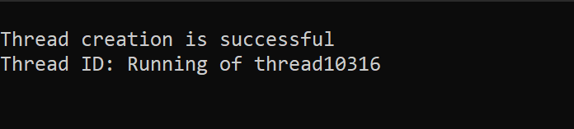

**Task # 02: Write a program that create 5 times thread with thread ID at once time.**

**Solution:**

#include <stdlib.h>

#include <stdio.h>

#include <pthread.h>

#include<iostream>

using namespace std;

void* start_thread(void* message)

{

cout << "Thread no: " << (int)message << endl;

return message;

}

int main(void)

{

pthread_t _id[5];

for (int i = 0; i < 5; i++)

{

pthread_create((_id + i), NULL, start_thread, (void*)(_id + i));

pthread_join(_id[i], NULL);

}

return 0;

}

**Output:**

**Task # 03: Run a loop that has program to print ten times thread ID, meanwhile use exit thread function that-should be interrupt when counter reaches on3rd.**

**Solution:**

#include <stdlib.h>

#include <stdio.h>

#include <pthread.h>

#include<iostream>

using namespace std;

void* start_thread(void* message)

{

cout << "Thread no: " << (int)message << endl;

return message;

}

int main(void)

{

pthread_t _id[5];

int ret;

for (int i = 0; i < 10; i++)

{

ret = pthread_create((_id + i), NULL, start_thread, (void*)(_id + i));

if (!ret)

{

// cout<<i<<" ";

pthread_join(_id[i], NULL);

if ((i + 1) % 3 == 0)

{

pthread_exit(NULL);

}

}

}

return 0;

}

**Output:**

